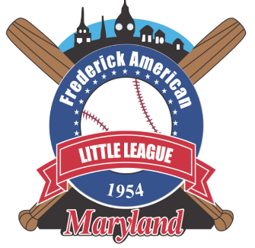

Frederick American Little League

Policy and Procedures

Reporting Abuse and Neglect

Purpose
Maintain compliance with the “Protecting Young Victims from Sexual Abuse and Safe Sport Act of 2017”

Scope
This policy applies to all Board Members, Managers, Coaches, Volunteers, and parents in Frederick American Little League including guests, fans, and spectators

Policy Statement
The Protecting Young Victims from Sexual Abuse and Safe Sport Act of 2017 mandates that all amateur sports organizations, which participate in an interstate or international amateur athletic competition and whose membership includes any adult who is in regular contact with an amateur athlete who is a minor must report suspected child abuse, including sexual abuse, within 24 hours to law enforcement.

An individual who is required, but fails, to report suspected child sexual abuse is subject to criminal penalties.

If an individual suspects a case of abuse within their league, they should report it to the appropriate child services organization and/or local law enforcement as well as their League President or League Safety Officer.

Definitions
Child Abuse and Neglect
- Physical injury, not necessarily visible, of a child under circumstances that indicate that a child’s health or welfare is harmed or at substantial risk of being harmed.
- The failure to give proper care and attention to a child, leaving a child unattended where the child’s health or welfare is harmed or a child is placed in substantial risk of harm.
- An act or acts involving sexual molestation or exploitation whether physical injuries are sustained or not.
- Identifiable and substantial impairment of a child’s mental or psychological ability to function.
- Finding credible evidence that has not been satisfactorily refuted that physical abuse, neglect or sexual abuse occurred.

Procedures
The appropriate authorities and / or law enforcement are to be immediately notified
The League President or League safety Officer must be notified immediately after authorities have been notified

Roles and Responsibilities
Who is required to report?
All individuals are required to report abuse. Any individual who fails to report suspected child sexual abuse is subject to criminal penalties.

Who is permitted to report?
Any individual who suspects a case of abuse within their league should report it to the appropriate child services organization and/or local law enforcement as well as their League President or League Safety Officer

What is the standard for reporting?
The circumstances under which a mandatory reporter is required to report vary by state. The DHHS summarizes two typical reporting standards, for both mandatory and permissive reporters:
(1) “the reporter, in his or her official capacity, suspects or has reasons to believe that a child has been abused or neglected”; and
(2) the reporter has knowledge of, or observes a child being subjected to, conditions that would reasonably result in harm to the child.”

Is the communication privileged?
The physician-patient privilege is superseded by the requirement to report child abuse.

Will the report be anonymous?
Frederick American leadership will make every effort to keep the reporter’s identity confidential however, in some cases, reporter’s identity may be released (i.e., by court order or by waiver and/or consent) as part of the investigative process.

Related Documents
- N/A

Revision History
Date | Revision Number | Description of Change | Approved By
1 January 2026 | REV I | Official documentation of policy | Rick Wilson / BOD

